

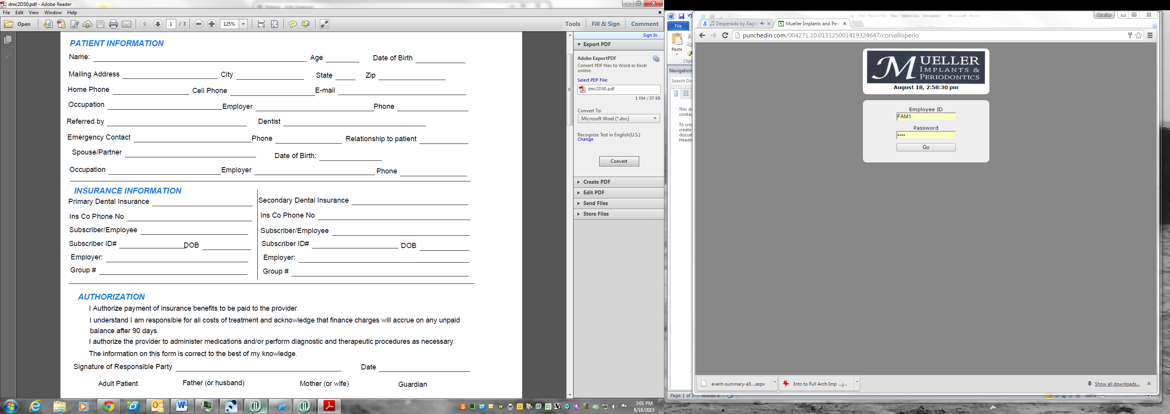

**Name: ____________________________ Page 2**

**Name: _________________________________ Page 3**

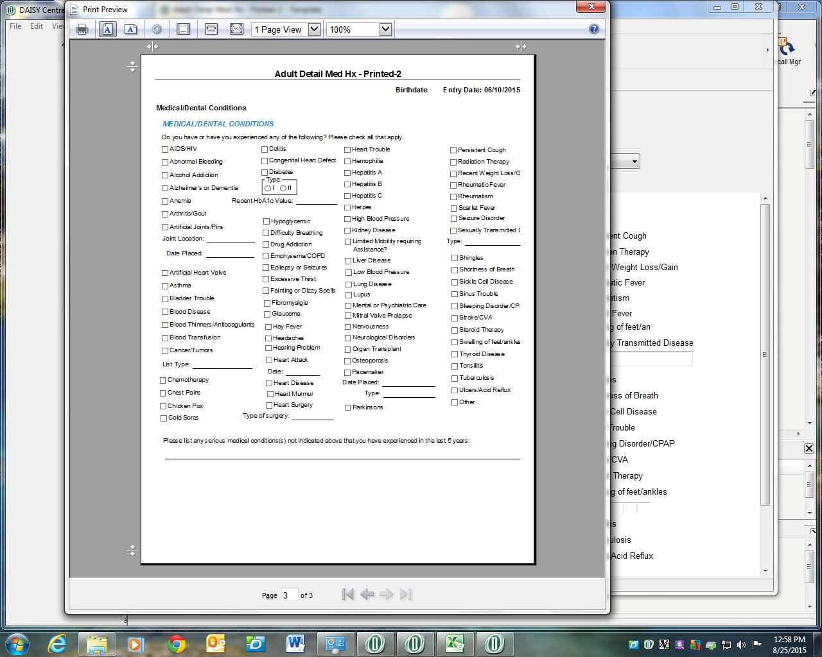

**____________________________________________________________________________________________________________________________________________________________________________________________________________________________________________________________________________________________________________________________________________________________________**

**Pharmacy: ________________________________Address: _____________________________City________________________**